FACTORS INFLUENCING AGRICULTURE
There are a number of factors which influence both crop and animal production, some of these factors include:
- Human factors
- Biotic factors
- Climatic factors
- Edaphic factors
1. HUMAN FACTORS
These are factors which are due to the behaviour of humans or how they do things and how they influence agriculture. These human factors are:
- Level of education and technology
- Health of the people
- Economic conditions
- Government policy
- Transport and communications
- Cultural beliefs and religion
- Market forces
a) Level of education and technology
High level of education leads to:
- Accuracy in applying inputs and assessing results
- Helps in proper decision making and organization
- Better problem solution
- Better utilization of livestock feeds and fertilizers
- Understanding of technical language used in agriculture
- Development of skills for operating machines and their maintenance
- Increase in efficiency and minimizes costs
b) Health of the people
Today the biggest threat to farming is the HIV/AIDS, ill health makes people do little or no work. The general
Effect of HIV/AIDS and ill health on agriculture
- Shortage of farm labour
- Increase the cost of living through treatment, thereby lowering their purchasing power thus low demand for agricultural products
- Low standards of living leads to lack of motivation to invest in agriculture, thus increasing poverty
- Low food supply
- A lot of funds used to control it, instead of being used to develop agriculture
c) State of the economy
Economic conditions which have affected agriculture include:
- Collapse of cooperative societies which affected the sale of farm produce such as milk, sugar, cotton etc
- Liberalization of the economy, which has led to dumping of cheap products from other countries, this has caused the drop in price of agricultural products leading to low income to farmers
N/B: Kenya can benefit from liberalization by:
- Producing goods of high quality and selling them competitively
- Diversification
d) Government policy
These are the laws which are put in place by the government that govern the production, marketing and distribution of agricultural products.
The policies that the government can put in place which can encourage the agricultural production include:
- Heavy taxation of imports to prevent dumping of cheap goods into the local market
- Subsidizing the growing of local crops thus making them affordable to farmers
- Enact policies to enforce the production of high quality products
- Put in place, policies aimed at conservation of natural resources in order to sustain agriculture
- Stepping up disease, parasite and pest control e.g. through quarantine, vaccination etc
e) Transport and communication
Transport and communication plays an important role in conveying agricultural products i.e.
- Railway lines are good for transporting bulky goods to long distances
- Airways are also efficient for air lifting horticultural products
- Weather roads are necessary to transport farm produce to factories
N/B: proper transport and communication therefore will promote the development of agriculture, the electronic media e.g. radio, TV, internet, all need to be cheap and affordable to all farming areas.
f) Cultural practices and religious beliefs
- The society’s beliefs and culture may also affect agriculture e.g. Muslims do not eat pork and therefore may not see the need for rearing pigs even if pigs are very productive.
- Pastoral communities also only keep animals and may find it difficult to diversify to crop farming even if it is profitable.
N/B: A combination of the above factors may retard agricultural development
g) Market forces:
The local demand and supply of agricultural produce will also affect the level at which farmers produce, also the international demand e.g. of Kenyan coffee, Tea will affect how much the farmers produce.
Demand –quantity of goods and services that consumers are able and willing to buy at a given price over a given period of time
Supply –quantity of goods producers are able and willing to put into the market at a given price over a period of time
2. BIOTIC FACTORS
These are factors caused by living organisms, living both in and on the soil surface.
These organisms include:

- Pests
- Parasites
- Predators
- Decomposers
- Pathogens
- Pollinators
- Nitrogen fixing bacteria
- Burrowing animals

- Pests
Effects of pests
- They feed on plants lowering both the quality and quantity of produce
- They transmit diseases
- Injure the plants, thus exposing them to secondary infection
- Increases the cost of production e.g. through buying chemicals to control them
- Parasites
- Some living organisms e.g. ticks also acts as parasites to animals thereby transmitting diseases

- Predators
- Predators kill livestock lowering production. Some predators kill pests and parasites assisting in their control

- Decomposers
- They decompose the organic matter in the soil e.g. the decomposers

- Pathogens
- Cause soil borne diseases
- Reduces the quality of agricultural products and even death of crops and livestock e.g. viruses ,bacteria ,fungi

- Pollinators
- Some insects and birds also act as pollinators to flowering plants thus enabling cross pollination

- Nitrogen fixing bacteria
- Cause nitrogen fixation in the soil
- Found in leguminous plants e.g. beans ,peas

- Burrowing animals
- Encourage aeration through burrowing into the soil

3. CLIMATIC FACTORS
These are factors due to the changes in the climate. Climate is the weather condition of a place taken over a long period of time. These climatic factors include:
- Rainfall
- Temperature
- Wind
- Humidity
- Light

a) Rainfall
Rainfall is very important in agriculture production as it ensures supply of water required by all life processes. Aspects of rainfall
i) Rainfall reliability
ii) Rainfall amount
iii) Rainfall distribution
iv) Rainfall intensity
i) Rainfall reliability
This is the assurance that rain will fall come the expected time
Reliability of rainfall determines:
- Time of land preparation
- Time of planting
N/B: when rainfall fails to follow the expected patterns, there is usually heavy crop failure and loss of livestock.
ii) Rainfall amount
Rainfall amount is the quantity of rainfall that falls in a given area within a year. It is measured in mm/year. Rainfall amount determines:
- Type of crop to be grown
- Type of animals reared
iii) Rainfall distribution
Rainfall distribution refers to how the rainfall was spread throughout the year. It determines the crop variety grown in an area
iv) Rainfall intensity
Rainfall intensity is the amount of rain that falls in an area within a period of 1 hour. It is measured in mm/hr.
High rainfall intensity causes: damage to crops, and also soil erosion
b) Temperature
This is the hotness or coldness of a place measured in degrees Celsius or centigrade
N/B: All crops thrive well under certain range of temperature known as cardinal range. These crops require narrower ranges of temperature within the cardinal range this is called optimum range.
Effects of low temperature on crop production
- Slow growth rate of crops as process like photosynthesis etc will be slow
- High incidences of diseases infection to crops e.g. Elgon die back, CBD, hot and cold diseases in coffee
- Quality of crops e.g. tea, pyrethrum improves with the lowering of temperature
Effects of high temperature on crop production
- Increase evaporation leading to wilting in crops
- Increase rate of growth or hasten the maturity of crops
- Improve the quality of crops such as pineapples
- Causes incidences of diseases infection e.g. leaf rust in coffee and pest infestation e.g. aphids in vegetables
c) Wind
Wind is air in motion.
Effects of wind
- Causing lodging in cereals and damage to crops
- Blowing away and bringing in rain bearing clouds
- Acting as an agent of seed dispersal
- Acting as agent of pollination
- Increasing the spread of pest and diseases
- Destroying farm structures by carrying away roof tops
- Also causes a cooling effect
d) Humidity
- Humidity is the amount of water vapour in the air at a given temperature.
- Relative humidity is the amount of water vapour held in the air at a given temperature compared to what it would hold when saturated
- Evaporation is the loss of water from the soil surface in form of water vapour
- Transpiration is the loss of water vapour through the leaf pores
- Evapotranspiration is the loss of water vapour both from the soil and leaf pores
N/B: humidity influences:
- Rate of evapotranspiration
- Temperature of a given area
e) Light
Light provides energy required for photosynthesis
Aspects of light
i) Light intensity
ii) Light duration
iii) Light wavelength
i) Light intensity
This is the strength in which light is harnessed by chlorophyll for the purposes of photosynthesis.
N/B: The rate of photosynthesis increases with increase in light intensity up to where other factors become limiting e.g. water.
ii) Light duration
This refers to the period during which light is available to plants per day. The duration is usually 12 hours in a 24 hour day. Plant varieties are classified into:
Short day plants: requires less than 12hrs e.g. soya beans, rice, tobacco
Long day plants: requires more than 12hrs of day light e.g. some wheat varieties
Day neutral plants: requires 12hrs of light e.g. coffee, maize, beans etc
iii) Light wavelengths
Chlorophyll only absorb certain wavelengths of light which are not present in artificial light a part from ultra violet or infra red light
N/B: light influences:
- Rate of photosynthesis in green plants
- Flowering of plants
- Performance of livestock e.g. growth rate and laying % in poultry
4. EDAPHIC (SOIL) FACTORS
Soil is derived from Latin word solum
Solum means floor
Soil is the natural, consolidated material that originates from weathered mineral rock and decomposing organic matter.
Importance of soil
- It’s a natural medium on which seeds germinate and roots grow.
- It supplies plants with the mineral nutrients necessary for crop growth
- It provides water, air, and warmth for small animals, micro organisms and plant roots to sustain life
- It provides anchorage to plants
- It also shelters many micro organisms
SOIL FORMATION
- Soil is formed through the process of weathering and decomposition of organic matter
- Weathering is both chemical and physical transformation that take place in the rocks, converting the components minerals into soils
- Decomposition is the decaying/rotting of organic matter.( remains of dead plants and animals) that break down to form soil
Types of weathering
- Physical weathering
- Biological weathering
- Chemical weathering
a) Physical weathering
Agents of physical weathering

i) Water
ii) Moving ice
iii) Wind
iv) Temperature

i) Water
- Running water wears away the rocks over which it flows by rolling stones and hand particles on them.
- Rain water dissolves carbon dioxide and forms weak carbonic acid which falls into rocks and dissolve them
- Moving ice also has a grinding effect
- When it rains, the rain drops hit the ground with force
- Rainfall erodes soil surfaces
ii) Wind
Strong winds carry rock dust which hit hard on the surface of rocks which then break down to form soil.
iii) Temperature change
- Due to temperature changes taking place within the rocks, they crack and crumble to form soil.
- Also in cold places, the water in rocks freezes and expands which then produces pressure on rocks then they break to small particles
b) Biological weathering
This is carried through plants, animals and man’s activities
- Large animals e.g. elephants, buffalos, cattle etc when they move, cause pressure on the rocks causing them to break down
- Man’s activities like mining ,cultivation and construction of buildings, roads, reduce the size of rocks into smaller particles
- Microorganisms e.g. bacteria and fungi assist in decomposition of remains to add humus to soil
- Plant’s root forces their way into rock crevices causing the cracking of rocks
- Earthworms mix up organic matter with mineral particles
Q. List four ways by which biological agents can enhance the process of soil formation
- Movement of animals in large numbers exert pressure on rocks thus breaking them
- Decomposition of plant and animal remains by soil micro- organisms
- Physical breaking of rocks by roots of higher plants
- Man’s activities e.g. cultivation, mining and road construction
- Mixing up of soil by animals e.g. earth worms and termites

Q. State four roles played by living organisms in the process of soil formation.
- Large animals exert pressure on rocks causing small fragments to disintegrate.
- Man’s activities e.g. mining reduce the size of the rocks into smaller particles.
- Bacteria and fungi initiate breakdown of organic matter on the surface of the soil to humus
- Termites bring to the surface large quantities of leached nutrients from subsoil to top soil.
- Earthworms feed on plant tissues and their waste cements soil particles.
- Roots exert pressure on rocks causing splitting of rocks.
- Roots produce acids in the soil which dissolves minerals from rocks.
- Nitrogen fixing bacteria Fix nitrogen in the soil
- Provide nutrients in the soil when they die
- Their waste matter adds nutrients to the soil
- Their burrowing activities increase the breakdown of rock particles and improve water infiltration
- Plant leaves decay to form organic matter
- Plant roots hold the soil firmly preventing soil erosion

c) Chemical weathering
This is weathering which takes place due to chemical decomposition or change in the chemical structure of the rocks
Types of chemical weathering

i) Carbonation
ii) oxidation
iii) Hydration
iv) Hydrolysis
v) Dissolution

i) Carbonation
When it rains, rain water combines with free carbon (iv) oxide in the air to form a weak carbonic acid e.g.
Rain water + carbon (iv) oxide carbonic acid
H₂O + CO₂ H₂CO₃
The weak carbonic acid reacts with limestone found in the rocks to form calcium bicarbonate e.g.
Weak carbonic acid + Limestone calcium bicarbonate
H₂CO₃ + CaCO₃ Ca(HCO₃)₂
Calcium bicarbonate formed from this reaction is soluble in water and the process effectively dissolves the rock minerals
ii) Oxidation
This is common in rocks having iron. Oxygen reacts with iron which is in ferrous state. This process forms unstable crystal which is easily decomposed and disintegrated
iii) Hydration
Minerals in rock combine with water to form hydrated compounds. Hydrated compounds so formed are weaker than the original form and these are then acted upon by physical or mechanical agents of weathering
iv) Hydrolysis
This is the reaction of minerals with water which then undergoes weathering process through other agents. Also called solution formation
v) Dissolution
The minerals in the rock dissolve in water leaving behind unstable rock, which can break easily.
FACTORS INFLUENCING SOIL FORMATION

- Parent material
- Climate
- Topography
- Time
- Living organisms

1. Parent material
This influence the chemical and physical properties of soil which will in some instances control the type of natural vegetation in an area which results in gradual formation of soil
Importance of parent rock materials
- Determine soil texture
- Determine soil colour
- Determine soil depth
- Determine soil mineral composition

2. Climate
Climate factors like rainfall, temperature, light and relative humidity and wind are all important in soil formation.
They affect the type and rate of weathering
3. Topography
Topography may either increase or delay the effects of climate on soil reaction e.g. factors like slope, degree of exposure or shelter may influences the degree of soil erosion which leads to shallow or deep soils. Topography also affects the movement of products of weathering which consist of soluble and solid particles. It therefore affects the soil depth and type of vegetation
4. Time
The length of time over which the soil forming processes have been in action affects the age of the soil. Where the soil forming processes have been taking place for a long time, deep mature soils can be found.
5. Living organisms
Living organisms affect accumulation of organic matter and also profile mixing. The micro organisms e.g. rhizobium add nitrogen to the soil
Vegetation cover also reduces surface erosion and this in turn mineral removal is reduced. Therefore the nature and number of organisms growing on and in the soil play a big role in the kind of soil that develops
SOIL PROFILE
Soil profile is the vertical arrangement of soil layers. The layers are called horizons
There are four broad groups of horizons, namely: A, B, C, and D
Top soil ----------- horizon A
Sub soil ----------- horizon B
Substratum ------ horizon C
Parent rock ------ horizon D
Cross – section of soil profile
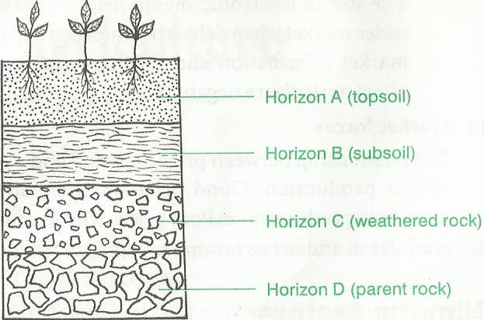
Superficial layer
1. Superficial layer
- This is a layer consisting of dry and decayed organic matter covering the soil surface
- Forms where the soil is under vegetation cover or forest

2. Top soil (horizon A)
- This is the top layer of the soil.
- It is dark in colour because it contains humus in it.
- It has many living organisms and plant nutrients
- Well aerated
- Most plant roots are found here
- This layer of the soil has good crumb structure and is quite permeable to air and water.

3. Sub soil (horizon B)
- Its below the top soil
- Has no humus and usually orange brown in colour
- It has few living organisms and deeper growing roots of plants
- It may have an impermeable layer called the hardpan
- Some time leached minerals accumulate here ,hence called layer of accumulation
- Has little organic matter due to absence of microorganisms
Causes of hardpan
- Working the soil when wet with heavy machinery
- Cultivation at the same depth throughout
Disadvantages of hardpan
- Hinders air circulation in the soil
- Prevent crop root penetration
4. Weathered rock (substratum)
- This layer is found beneath the sub soil.
- It is made of partly weathered rock with no humus.
- It is hard and therefore impermeable to water.
- Roots of big trees may reach this layer and draw water during dry season

5. Parent rock
- This is the bedrock.
- The soil is formed from this rock.
- Ponds of water are often formed on this rock.
- Roots of some plants in very dry areas reach these ponds to absorb water

Transitional zone
This is a zone between any two bordering soil layers, whereby one layer gradually merges into the next one in the series
Influence of profile on crop production
- Most plant nutrients are found in the top soil
- The deeper or thicker the profile, the better it is for crop production
- Loosely packed soil allows for easy root penetration
- The nature of the bed rock also determines the nutrients availability in the soil.

SOIL CONSTITUENTS
Soil is made up of the following:
1. Mineral matter
2. Soil water
3. Soil air
4. Organic matter
5. Living organisms
1. Mineral matter
These are inorganic compounds formed from the weathering of rocks. They differ in size ranging from an clay to gravel. They include:
- Clay
- Silt
- Sand
- Gravel
Influence of mineral particles on crop production
They make the main frame work of the soil
They hold plant roots firmly together
How to determine the mechanical composition of the soil
Using various sieves of different diameter
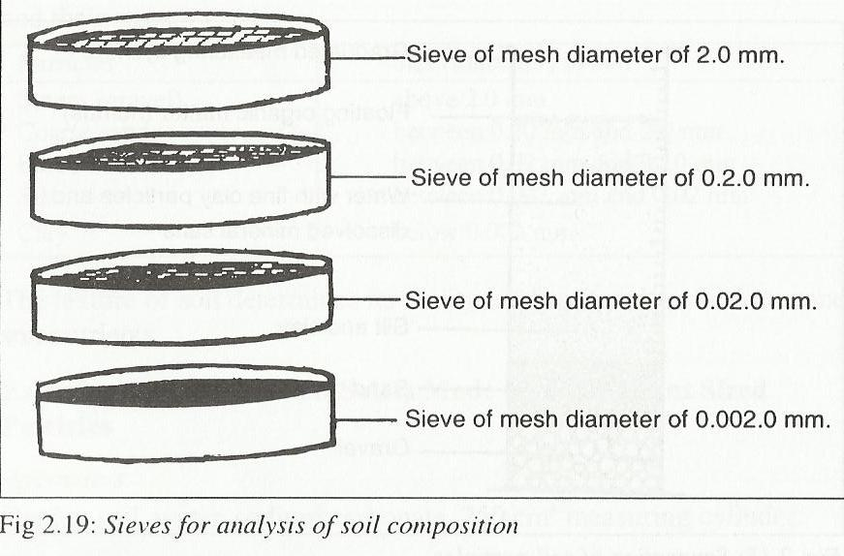
2. Soil water
Soil has water which comes from rainfall and also from irrigation in dry lands
Forms of soil water
- Superfluous water
- Capillary water
- Hygroscopic water
Superfluous water
- This is water which is held by gravity. It is also called gravity water.
- Its easily lost because its loosely held by soil particles
- Its readily available to plants but not useful because too much of it limits aeration
Capillary water
- This is water occupying the micro pores. It is held by soil particles
- It’s the water available to plants. It is also referred to as available water
Hygroscopic water
This is water which forms a thin film around the particles. It is not available to plants
Functions of water to plants
- Soil water maintains the life of plants
- It is used as a raw material for protein for diffusion of mineral salts and oxygen into the root hairs and the mineral salts dissolved in water are conducted upwards to the leaves.
- It is also acts as a solvent for the diffusion of other substances from one part of plant to another
- It makes protoplasm and cell sap of the growing plants
- It keeps the cell turgid and thus supports plant
- Also cools the leaves of the plant during transpiration
Experiment 1 to find the percentage of soil water content
Apparatus: - dish, stirring, weighing balance, soil sample and heater or oven
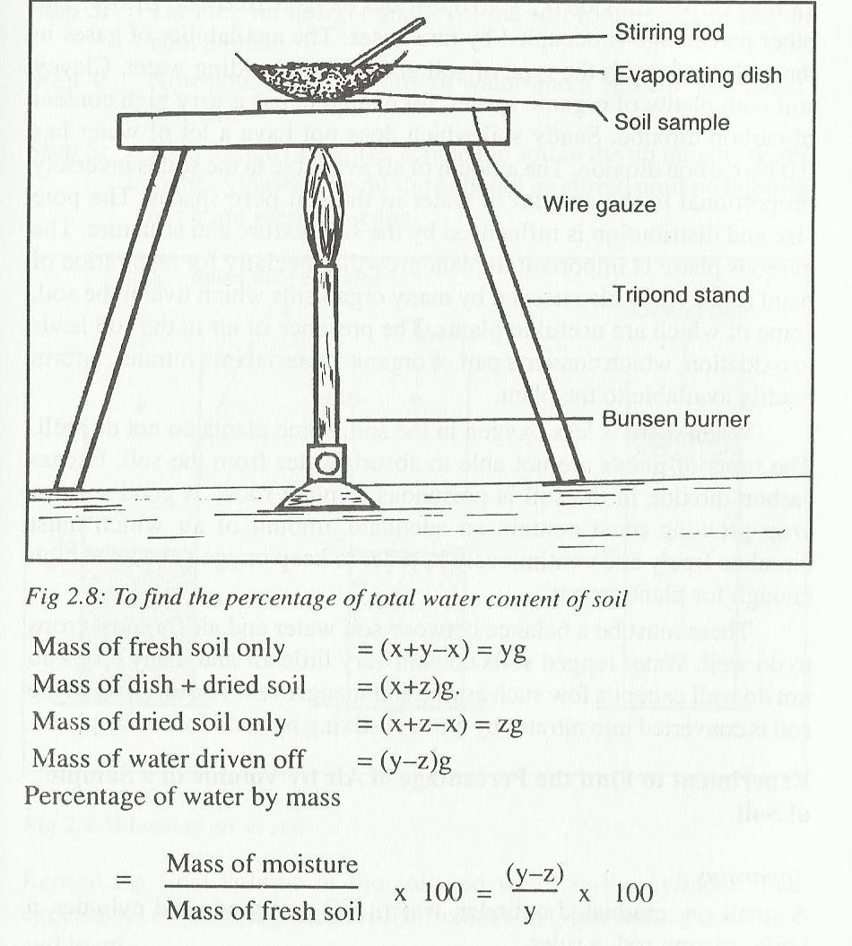
Procedure:
- Measure the mass of the dish
- Pour soil in the dish and weigh
- Half fill the dish with water
- Heat up to about 105ºc
- Cool the sol with a dessicater then reweigh – repeat the process until you get a constant mass
3. Soil air
The spaces between the soil particles are filled with air. These include
Oxygen ----------------- 20.6
Carbon dioxide ------- 0.6 – 0.6
Nitrogen -------------- 78.6
Other rare gases.
The amount of air available in the soil is inversely proportional to the amount of water in rhe soil pore spaces.
Oxygen present in the air is essential for the respiration of roots and other living organisms in the soil
Nitrogen in the soil is converted into nitrates by the nitrogen fixing bacteria
Air is also needed by the micro organisms living in the soil
Excess carbon dioxide in the soil is poisonous to plants
Experiment 2: To find the percentage of air by volume in a soil
Apparatus
- Small tin
- Graduated cylinder
- Knife and stirring rod
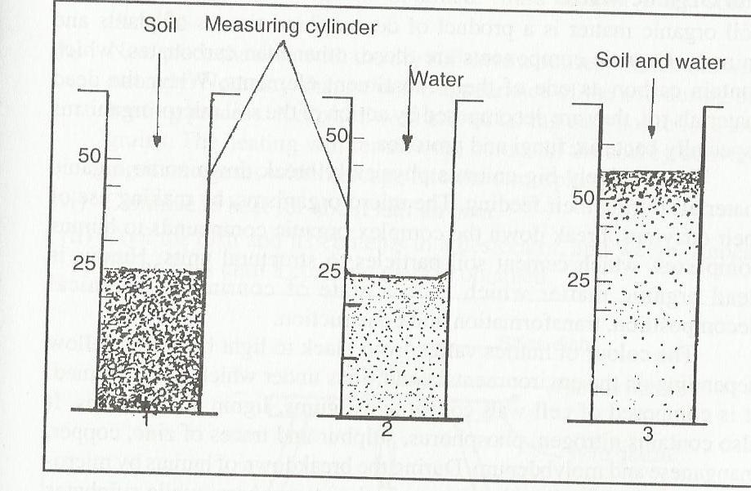
Procedure
- Turn the empty tin upside down and press firmly into the ground until the tin is completely filled with soil
- Turn the tin upright and level the soil to the brim of the tin with a ruler
- Pour 250cm³ of water into a cylinder and scrap off soil into the water until no bubbles comes out
- Record the final volume of soil and cylinder
4. Soil organic matter
- Organic matter in the soil is the remains of the dead plants and animals plus their waste products
- Humus is the decayed organic matter
Importance of organic matter
- Decomposes to release nutrients to plants
- Makes the soil lighter to cultivate
- Also improves the soil structure
Experiment 3: To find the % of humus content in the soil
- Apparatus
- Dish
- Garden soil
- Tripod stand
- Wire gauze
- Bunsen burner
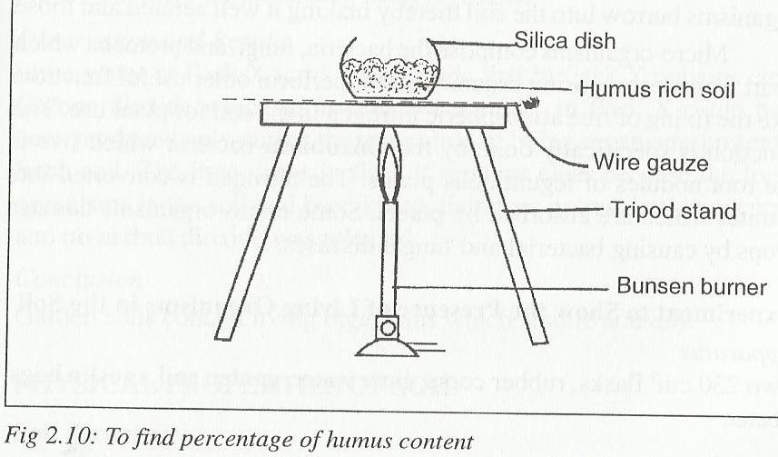
Procedure
- Weigh the empty dish
- Put the garden in the dish and reweigh
- Place in an oven at about 105ºc
- Cool in a dessicater and reweigh
- Repeat the process several times until a constant weight is obtained
- Note the difference weight
5. Soil living organisms
There are two types of living organisms in the soil namely:
- Macro organisms
- Micro organisms
Macro organisms are large organisms found in the soil e.g. rodents, earthworms, ants, termites, plant roots etc
Micro organisms are tiny organisms which can only be seen with the help of a microscope they include bacteria, fungi, protozoa etc.
Importance of soil living organisms
- They barrow in the soil and aerate the soil and improve drainage
- They help in the decomposition of organic matter
- Some also fix nitrogen in the soil e.g. the nitrogen fixing bacteria
Experiment 4: To show the presence of living organisms in a soil sample
Apparatus
- 2 flasks
- Rubber cork
- Muslin bag
- Heater
- Lime water
- Garden soil
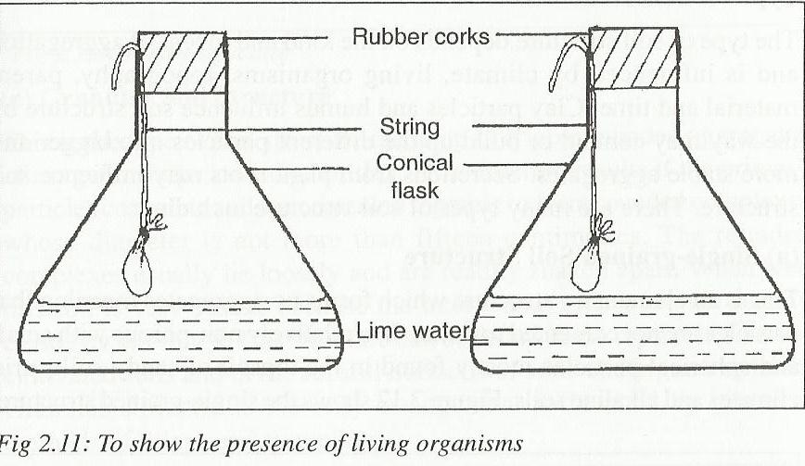
Procedure
- Put a handful of garden soil in two muslin bags labeled A and B
- Heat the soil in muslin bag B strongly to kill the micro organisms
- Suspend the two bags in the flasks also labeled A and B, the flasks should contain lime water
- Leave the apparatus for 4hrs
Observation
- Lime water in flask A turns milky
- Lime water in flask B remains clear
Conclusion
- Lime water in flask A turns milky because of the presence of carbon dioxide produced during respiration. Carbon dioxide turns lime water milky
- Lime water in flask B remained clear since the living organisms were killed during heating so no respiration took place
Physical properties of soil
These include:
1. Soil structure
2. Soil texture
3. Soil colour

1. Soil structure
This is the way in which the individual soil particles are arranged
Types of soil structure
- Single – grained structure
- Crumby structure
- Granular structure
- Platy structure
- Blocky structure
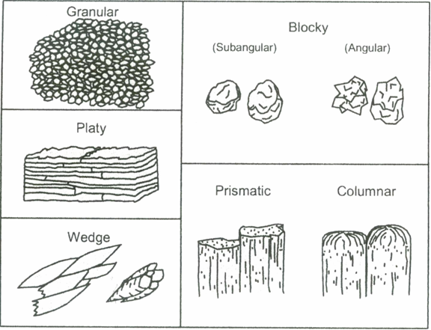
(a) Single – grained structure
In this structure, the particles are not cemented together. They exist as individual grain. They form no aggregates and are non porous.
They are mostly found in top soils of sandy soils and in arid climate and in alkaline soils
(b) Crumby structure
This type consists of small, soft porous aggregates of irregular shapes. They are not closely fitted together
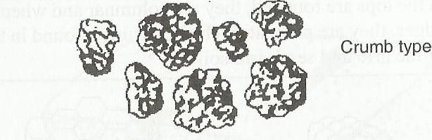
(c) Granular structure
This is made of friable rounded aggregates of irregular shapes called granules. It is formed when particles coagulate and are cemented together to form rounded aggregates whose diameter is not more than 15cm
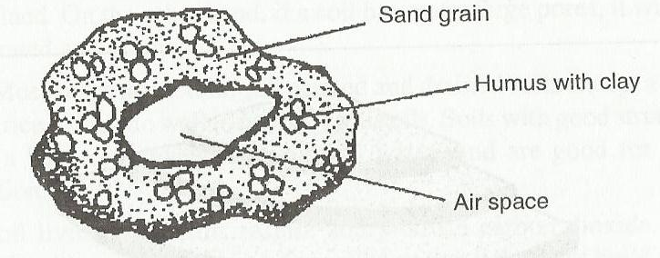
When wet it becomes porous since the spaces are not readily closed by swelling. The structure is found in top horizon in cultivated soils and in the sub- soil under grass. The structure is not porous and is usually affected by tillage.
(d) Prismatic structure
This is where the structure aggregates are arranged vertically. The primary particles are vertically oriented forming distinct columns which vary in length depending on the type of soil.
The structure is found in sub soil of arid and semi arid soils
N/B: If the tops are rounded, they are called columnar. But if the tops have clear cut edges, the it is called Prismatic
(e) Platy soil structure
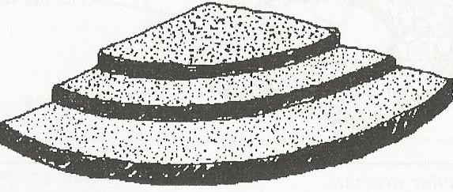
In this structure, the aggregates are arranged on top of one another on thin horizontal plates. The plates overlaps and impair permeability and hence drainage and root penetration. The structure is found in top soils of clay soil and forested area.
(f) Blocky structure
Here the aggregates are in form of rectangular blocks. The aggregates easily fit together a long vertical edges
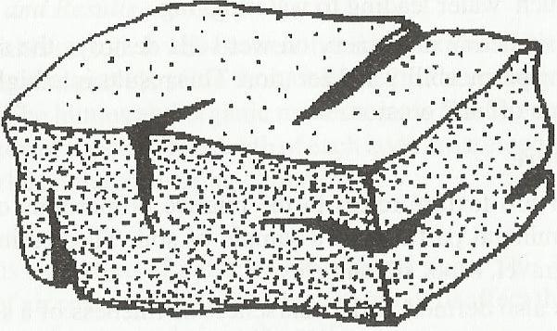
Influence of soil structure on crop production
- A loosely packed structure ensures good air circulation in the soil
- Good structure also ensures proper water holding capacity
- Good structure also gives proper root anchorage
- Good structure also reduces then soils liability to erosion
Factors that influence the soil structure
- Parent material
The physical and chemical properties of the parent rock will determine the type of structure being formed
- Soil forming processes
Processes which lead to soil formation will determine the type of structure being formed
- Climate
In areas where a lot of rainfall is followed by dry periods cracks tend to form giving rise to good structure which is well aerated
- Organic matter
Presence of organic will stabilize the soil structure
- Living organisms
Living organisms also help to decompose organic matter which intern improve structure
- Cultivation
The nature of cultivation e.g. digging channels results in a better structure
- Inorganic compounds
Presence of compounds like iron oxide have binding properties and help in the formation of granules
2. Soil texture
This refers to the relative proportion of various sizes of mineral particles in a soil.
Particles Diameter
- Clay 0.002mm and below
- Silt 0.002 ------ 0.02
- Fine sand 0.02 ------- 0.2
- Coarse sand 0.2 -------- 2mm
- Gravel 2 ---------- 20mm
- Stone 20mm and above
Determination of soil texture
Can be determined by:
- Mechanical analysis
- Chemical analysis
Mechanical determination of soil texture
Apparatus
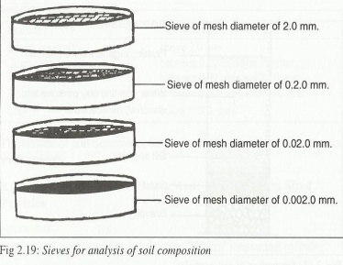
- Sieves of different diameter
- Containers
- Weighing balance
Procedure
- Put a known amount of soil sample in a container
- Pass the soil through a sieve of the smallest diameter and shake
- Weigh the soil that remains in the sieve
- Repeat the process using sieves of different diameter until all the soil I passed through
Observation
After every sieving it will be observed that a certain amount of soil remains in the sieve
Conclusion
Soil is made up of different sized particles of different diameter
Experiment 6: to show that soil is made up of different sized particles
Apparatus
- Measuring cylinder
- Sodium carbonate
- Garden soil
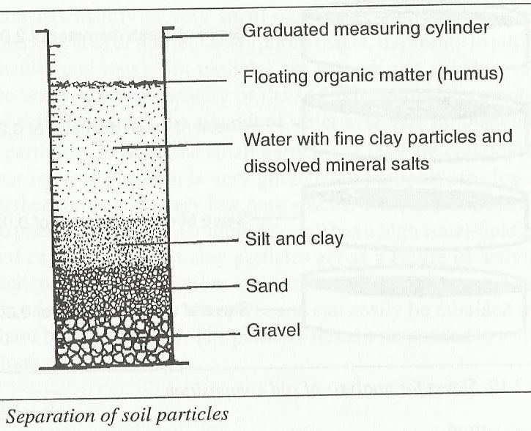
Procedure
- Put some soil sample in a measuring cylinder
- Add about 4 times its volume of water with sodium carbonate to aid in dispersion of particles
- Cover the mouth of the cylinder with the hand and shake vigorously for about 2min.
- Place cylinder on the bench for about 1hr or more to allow the contents to settle down
Observation
- At the end of the period, it will be seen that fractions have settled in layers
- The heavy, coarse gravels settle first, then followed in succession by sand, silt and clay
- The humus and organic matter remain floating in the water or on top of the clay
Conclusion
From the above observations, it can then be concluded that soil is a mixture of particles of different sizes.
Influence of soil texture on crop production
- Coarse soils have poor water holding capacity
- Very fine textured soils also have poor aeration
Soil colour
- Soil colour depends mainly on the mineral composition of the soil
- If the soil was made from a rock containing a lot of iron compounds, it tends to be brownish yellow, reddish or orange in colour
- Humus content also gives dark brown colour
- Soil colour influences temperature of the soil
Soil classification
Soil can be classified based on the following
- Soil structure
- Soil texture
- Soil colour
- Soil pH
According to structure, soils could be classified as granular, crumby, blocky, or platy soil structures
According to texture, a soil containing high proportion of sand particles is called sandy soils, if it contains high amount of clay then it is called clay soils
In terms of colour, soils could be either dark coloured soils or light coloured soils
Types of soils
- Sandy soils
- Silty soils
- Clay soils
- Clay loams
- Loamy soils
1. Sandy soils
- They have bigger particles
- Contains 50 – 80% sand, and 20 – 50% silt and clay
- Organic matter content is 0.1 – 3%
- Are well drained
- Are more prone to soil erosion have low water holding capacity
- They are slightly acidic
- Easy to cultivate but less fertile
How to improve sandy sols
- Add organic matter
- Addition of fertilizers
2. Silty loams
- They contain 20 – 30% sand
- Also contains 70 – 30% clay
- Has 0.1 - 4% organic matter
- They are fine textured, well drained and have a good water holding capacity
- They have moderately acidic ph
- Moderately fertile and aerated
3. Clay loams
- They contain 20 – 50% sand
- Clay and silt is 20 – 60%
- Has organic matter content of 0.1 – 6%
- They are fine textured
- Poorly drained and aerated
- Has capillarity and water retention
- They are rich in plant nutrients
- Are suitable for flood irrigation for rice growing
- This soil can be improved through drainage
4. Clayey soils
- Have clay content of more than 40%
- Have high water holding capacity
- Have crystalline and platy structure
- Expand when wet
- Crack when dry
- Get water logged easily
- Also suitable for flood irrigation
- Have high capillarity
5. Loamy soils
- They contain 30 -50% sand, 50 -70% silt and clay and 0.4% organic matter
- Are moderately textured and drained
- Are slightly acidic
- Have good water holding capacity
- Can be improved by planting cover crops and adding organic manures
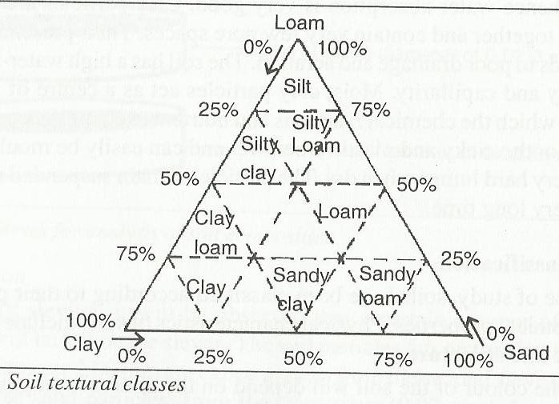
Experiment 7: To compare the porosity and water holding capacity of sand, loam and clay
Apparatus
- Measuring cylinder
- Funnels
- Cotton wool
- Dry sand, loam and clay

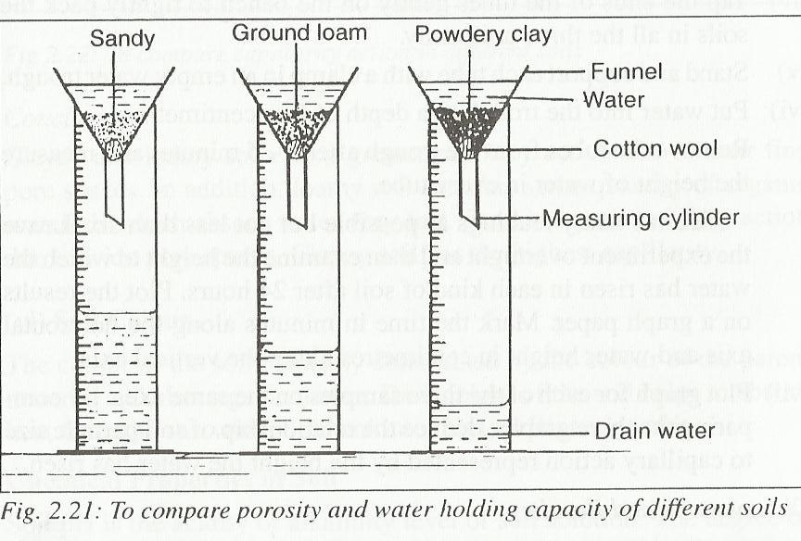
Procedure
- Place equal volumes of each soil in each funnel plugged with cotton wool
- Tap all the funnels persistently until all visible air spaces are filled up
- Stand each funnel in the open end of measuring cylinder and add 50cm³ of water into each funnel
- Note the time taken for the first drop of water through into the cylinder
Observation
After some time, it will be seen that water level is high in sand than the rest
Conclusion
Sandy soil is more porous than the other 2
Clay soil has the highest water holding than the other 2
Experiment 8: To compare the capillarity of sand, loam and clay
Apparatus
3 long cylinders
Dry sand, clay and loam
Water trough
Clock
Ruler
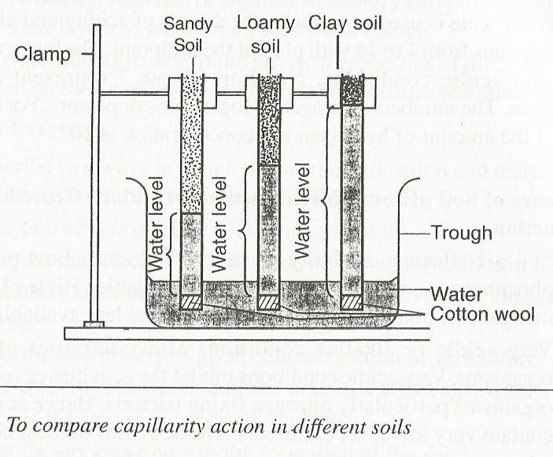
Procedure
- Close the lower end of each tube with a plug of cotton
- Fill each tube with different soils
- Tap the end of each tube gently in the bench to tightly pack the soils
- Stand and clamp each tube with a clamp and put in an empty water trough
- Poor water into the trough to a depth of 5cm
- Measure the height of water in each tube after 3 – 5min
- Take as many readings as much as possible
- Record the readings
Observations
- Water will be seen to be rising up the tubes
- It rises very fast in sand and loam in the first 3 – 5min. but very slow in clay
- After 2hrs water level will be higher in loam than in clay soil and least in sand
- Water rise continues in clay soil but stops after some time in loam
Conclusions
- Clay and loam have higher capillary action due to their fine pore spaces
- Sand has poor capillary action due to their large pore spaces
- Clay soil has the highest capillarity
Chemical properties of soil
- Soil pH
- Soil mineral content
1. Soil pH
- This is the acidity or alkalinity of soil solution
- Acidity is determined by hydrogen ion concentration while alkalinity is determined by hydroxyl ion concentration
Influence of soil pH on crop production
- Soil ph affects the availability of various nutrients e.g. low ph makes P, and molybdenum less available and high ph makes Mn, K, Fe and zinc less available
- Very low ph affects the activities of micro organisms e.g. nitrogen fixing bacteria
- Different crop species require different ph ranges
Ways of modifying pH
- Apply lime to raise the pH
- Apply basic fertilizers
- Apply sulphur to lower the pH
- Apply acidic fertilizers to lower the PH

